Functional Test for ESP32 Rainbow PCB Assembly

Required Equipment
- USB-C cable
- USB Power supply

Test Procedure

Step 1: Connect Over USB-C
- Plug a USB-C cable into the PCB’s USB-C connector.
- Connect the other end of the cable to a computer.
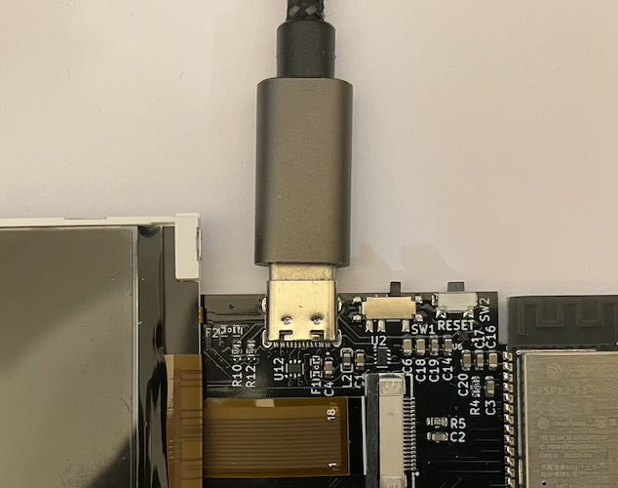

Step 2: Confirm Green LED D1 is Lit
1. Verify that green LED D3 (Power Indicator) is illuminated.
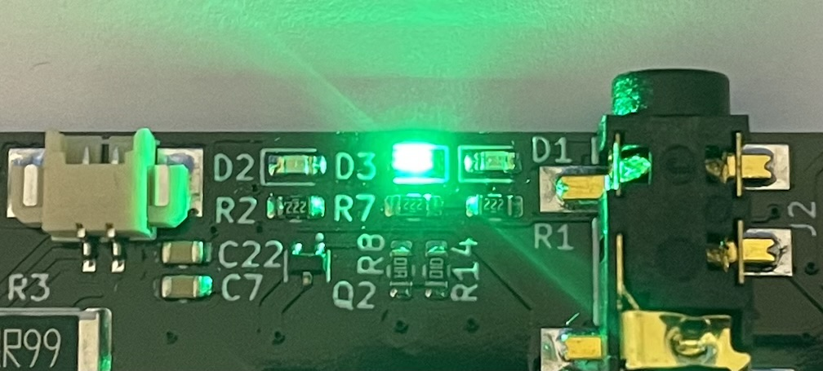

Pass Criteria:
- D3 is ON → Proceed to Step 3

Troubleshooting
- D3 is OFF → Check soldering on USB connector J1, ICs: U12, U2. Check test points 5v and PWR. Measured voltage should be 5v
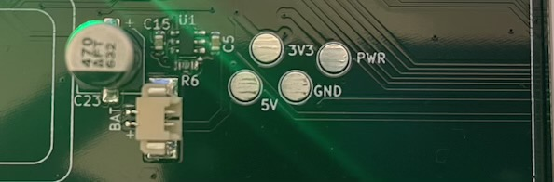

Step 3: Move Switch SW1 to Left Position
- Locate switch SW1 on the PCB.
- Move the switch to the left position.

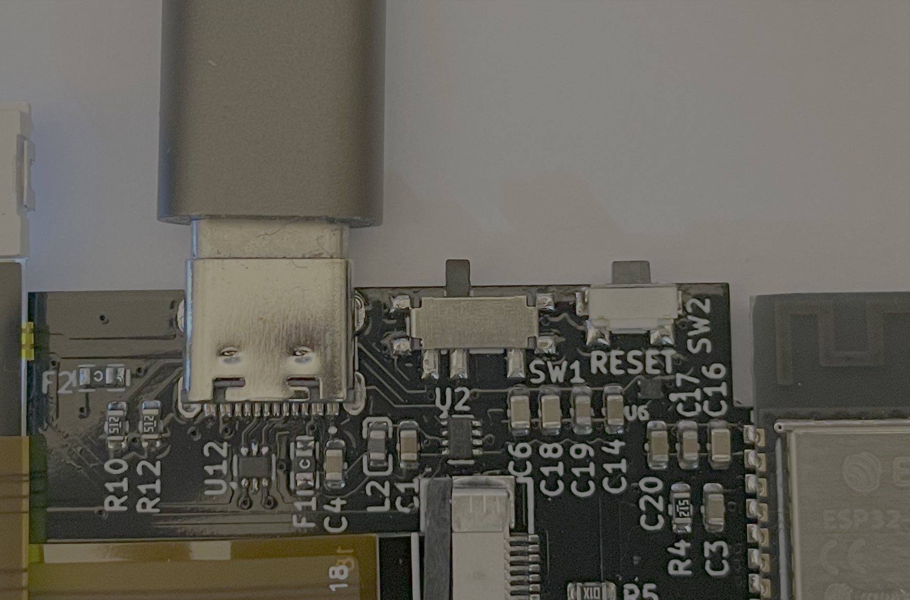

Step 4: Confirm Green LED D2 is Lit
- Verify that LED D2 is illuminated after moving the switch.

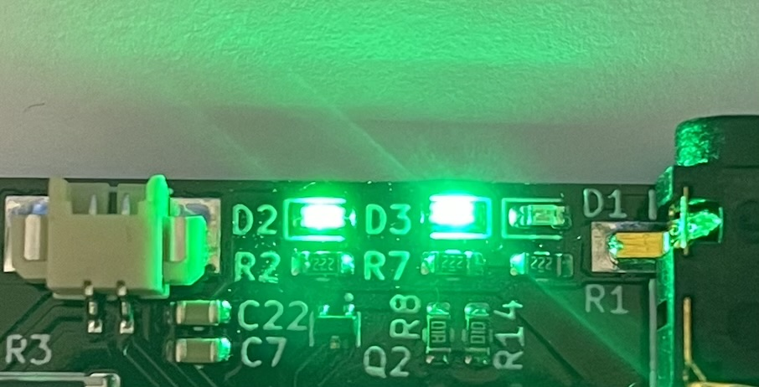

Pass Criteria:
- D2 is ON → Passed

Troubleshooting
- D2 is OFF → Check switch position. Check soldering on U6. Check test point 3V3



Step 4 Confirm USB device is present on PC
USB device should appear on the PC.

Pass Criteria:
- Device appears on the PC

Troubleshooting
- Check soldering on USB connector
- Check soldering on ESP32
- Check soldering on U12

